# Exercise 1- Creation of base table and dml operations

1.Create MY_EMPLOYEE table with the following structure

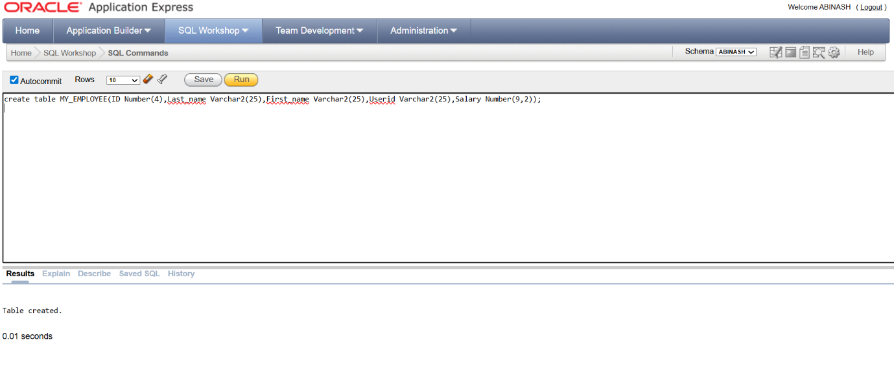

2.Add the first and second rows data to MY_EMPLOYEE table from the following sample data.

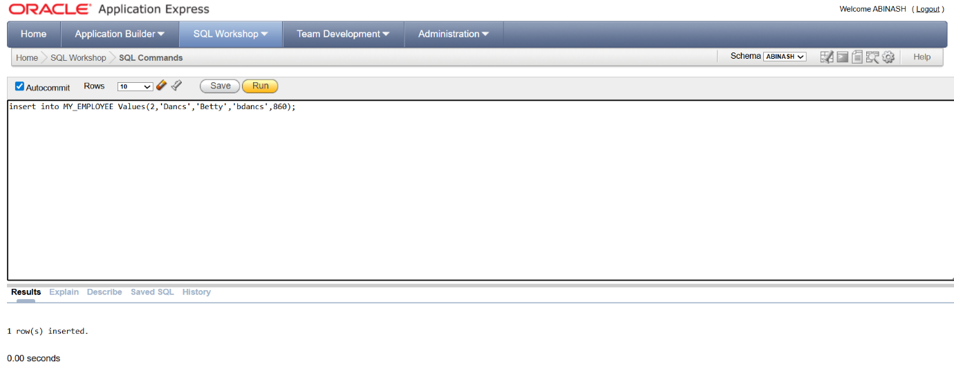

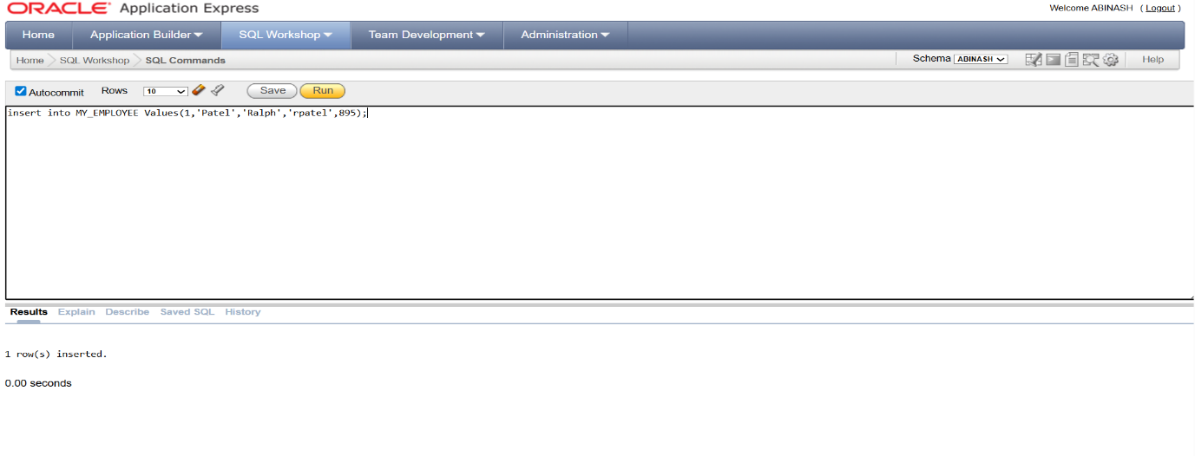

3.Display the table with values.

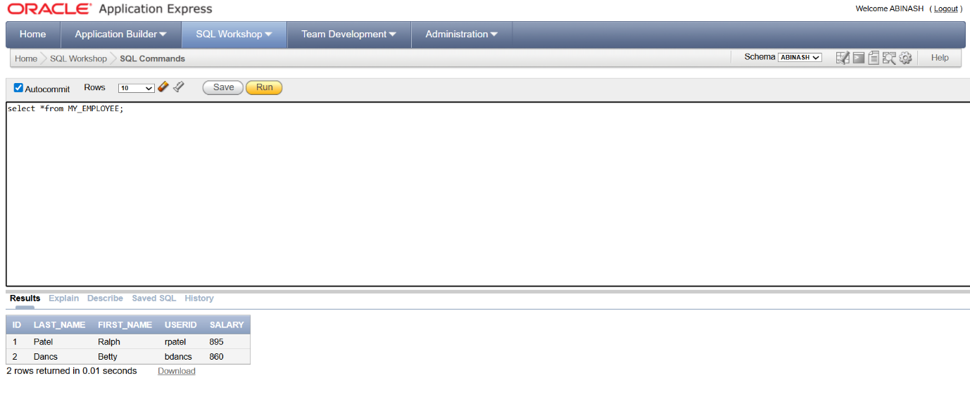

4. Populate the next two rows of data from the sample data. Concatenate the first letter of the first_name with the first seven characters of the last_name to produce Userid.

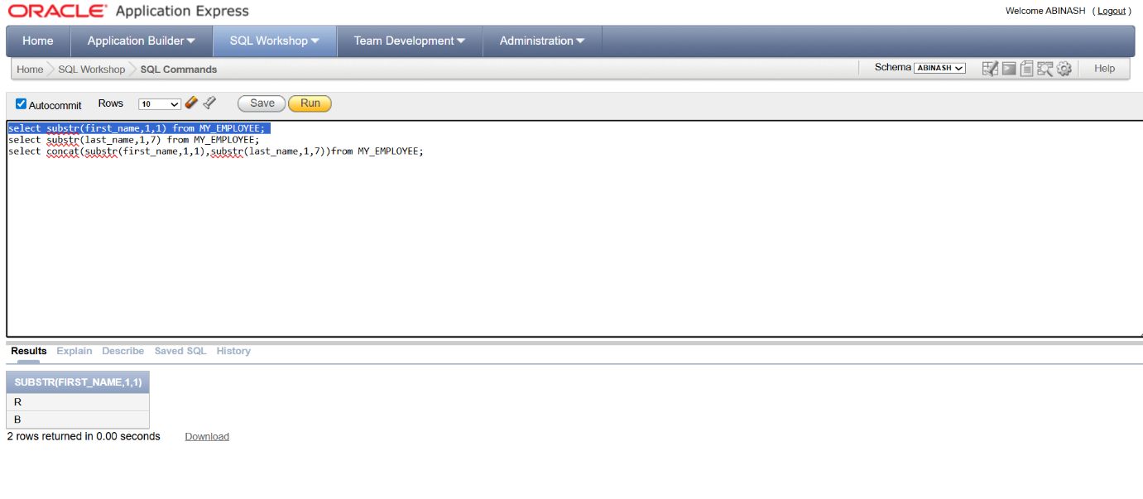

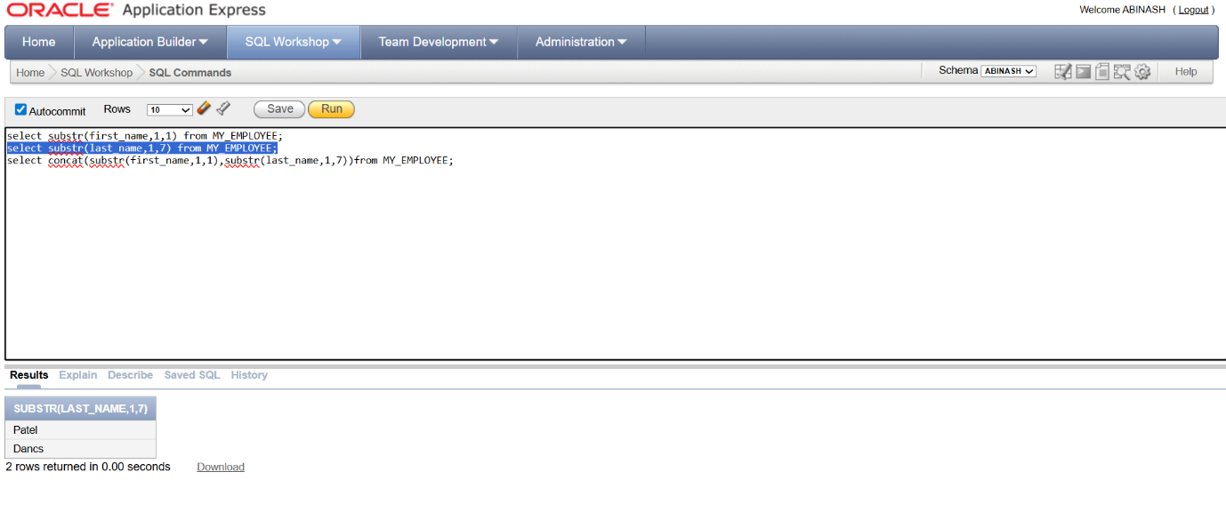

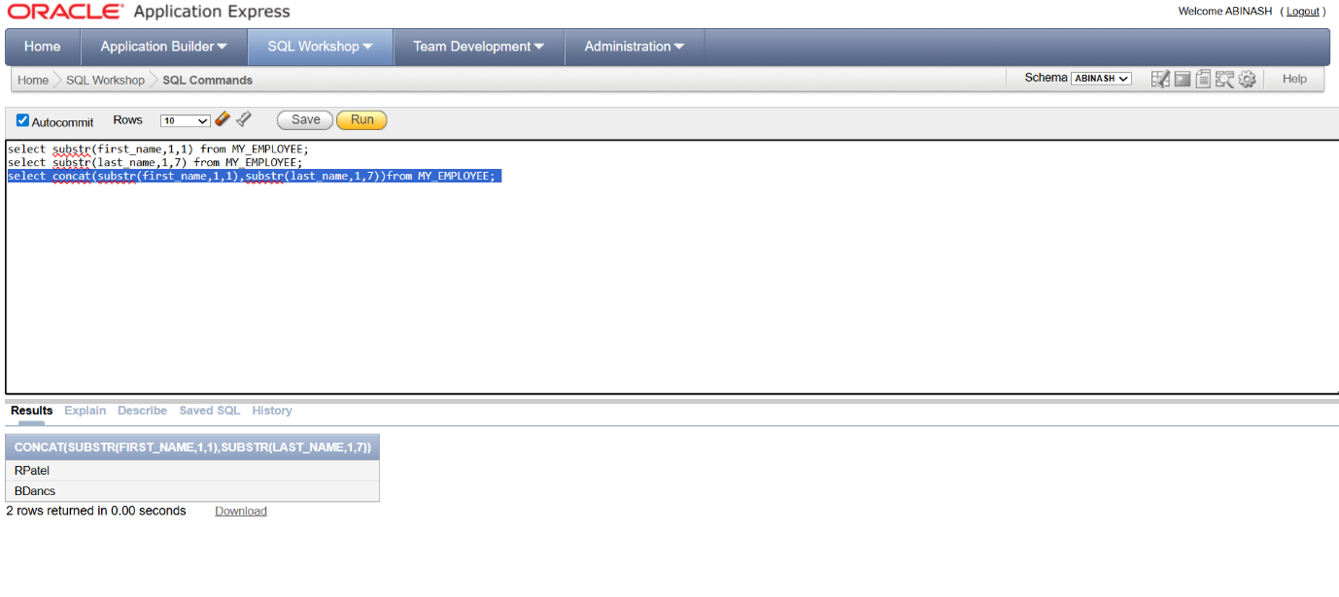

5. Make the data additions permanent.

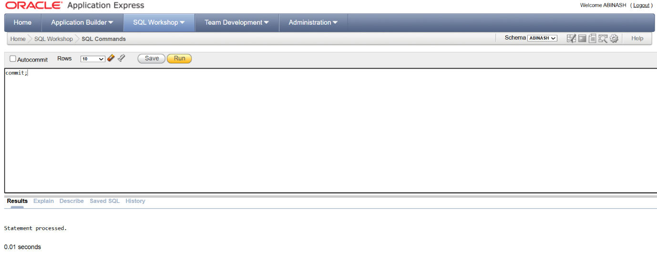

6. Change the last name of employee 3 to Drexler.

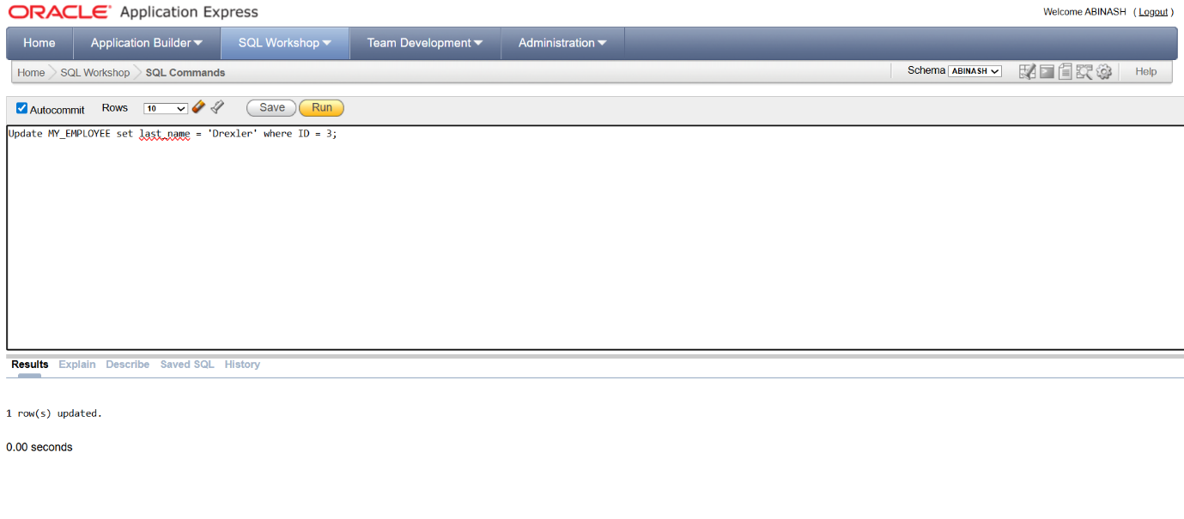

7. Change the salary to 1000 for all the employees with a salary less than 900.

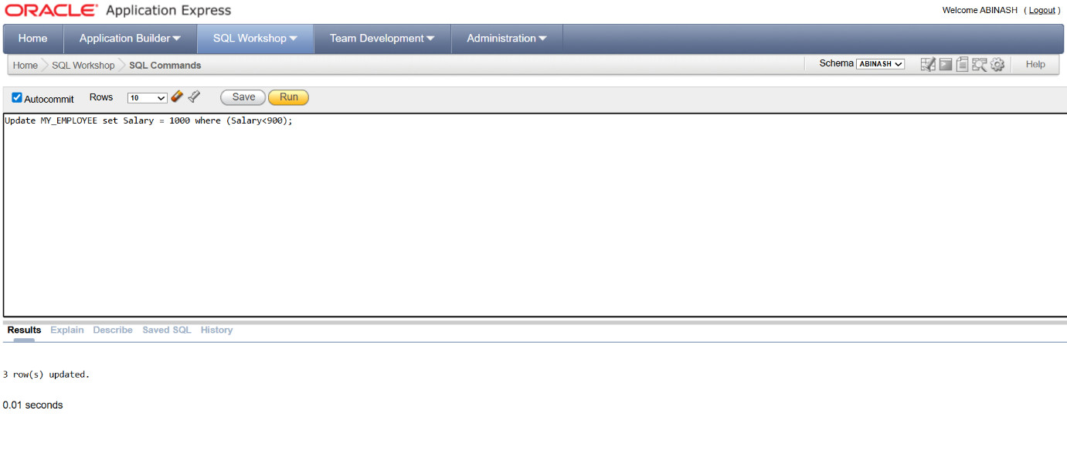

8. Delete Betty dancs from MY _EMPLOYEE table.

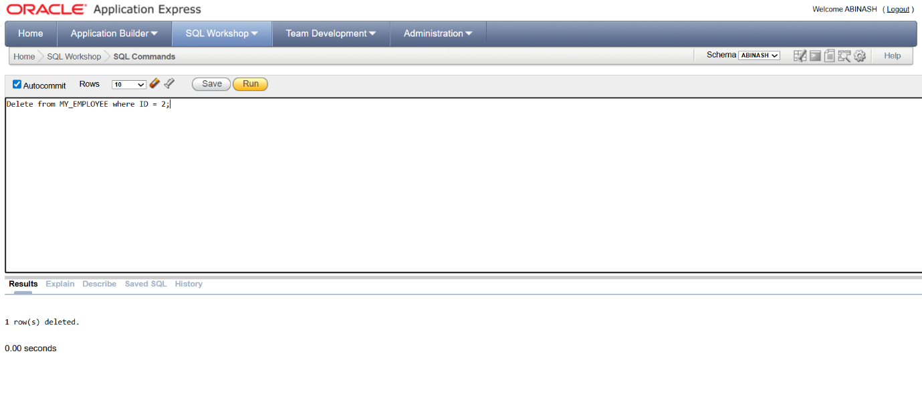

9.Empty the fourth row of the emp table

